ISTE-230 Introduction to Database & Data Modeling

## Practice Exercise # 5 – Normalization through 2NF

**Name:** Brian Zarzuela

For each problem below, given the original relation and functional dependencies, normalize the original and all resulting relations to 2NF. Be sure to use proper relational notation: RELATION(pkattr, attribute, *fkattr*). Include reference statements for foreign keys.

**Problem #1**

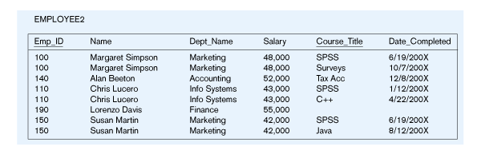

EMPLOYEE2(Emp_ID, Name, Dept_Name, Salary, Course_Title, Date_Completed)

Functional Dependencies:

Emp_ID, Course_Title 🡺 Name, Dept_Name, Salary, Date_Completed

EmpID 🡺 Name, Dept_Name, Salary

**YOUR ANSWER (Final set of relations normalized to 2NF):**

EMPLOYEE2(Emp_ID, Course_Title, Date_Completed)

EMPLOYEE2(Emp_ID) must exist in EMPLOYEE(Emp_ID)

EMPLOYEE(Emp_ID, Name, Dept_Name, Salary)

**Problem #2**

ENGINEER-SERVICE(empID, firstname, lastname, email, serviceID, servicename)

Functional Dependencies:

empID, serviceID 🡺 firstname, lastname, email, servicename

empID 🡺 firstname, lastname, email

email 🡺 empID, firstname, lastname

serviceID 🡺 servicename

**YOUR ANSWER (Final set of relations normalized to 2NF):**

ENGINEER-SERVICE(empID, serviceID)

ENGINEER-SERVICE(empID) mei ENGINEER(empID)

ENGINEER-SERVICE(serviceID) mei SERVICE(serviceID)

ENGINEER(empID, firstname, lastname, email)

SERVICE(serviceID, servicename)

**Problem #3**

Movie

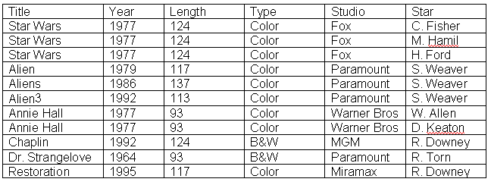

MOVIE(Title, Year, Length, Type, Studio, Star)

Functional Dependencies:

Title, Star 🡺 Year, Length, Type Studio

Title 🡺 Year, Length, Type, Studio

**YOUR ANSWER (Final set of relations normalized to 2NF):**

MOVIE(Title, Star)

MOVIE(Title) must exist in MOVIE-TITLE(Title)

MOVIE-TITLE(Title, Year, Length, Type, Studio)

**Problem #4**

APPOINTMENT(clientID, providerID, apptDate, startime, endtime, firstname, lastname, notes, street, city, state, zipcode, phone, fname, lname,cellnum, serviceID, servicename, price, duration, description, email)

Functional Dependencies:

clientID, providerID, apptDate, serviceID, starttime 🡺 endtime, firstname, lastname, notes, street, city, state, zipcode, phone, fname, lname, cellnum, servicename, price, duration, description, email

clientID 🡺 firstname, lastname, street, city, state, zipcode, phone, email

email 🡺 clientID, firstname, lastname, street, city, state, zipcode, phone

providerID, serviceID 🡺 price

providerID 🡺 fname, lname, cellnum,

serviceID 🡺 servicename, duration, description

**YOUR ANSWER (Final set of relations normalized to 2NF):**

APPOINTMENT(clientID, providerID, apptDate, startime, endtime, ~~firstname~~, ~~lastname~~, notes, ~~street~~, ~~city~~, ~~state~~, ~~zipcode~~, ~~phone~~, ~~fname~~, ~~lname~~,~~cellnum~~, serviceID, ~~servicename~~, price, ~~duration~~, ~~description~~, ~~email~~)

APPOINTMENT(clientID, providerID, apptDate, starttime, endtime, notes, serviceID, price)

APPOINTMENT(clientID) must exist in CLIENT(clientID)

APPOINTMENT(serviceID, providerID) mei SERVICE-PROVIDER(serviceID, providerID)

CLIENT(clientID, firstname, lastname, street, city, state, zipcode, phone, email)

PROVIDER-SERVICE(providerID, serviceID, price)

PROVIDER-SERVICE(providerID) must exist in PROVIDER(providerID)

PROVIDER-SERVICE(serviceID) must exist in SERVICE(serviceID)

PROVIDER(providerID, fname, lname, cellnum)

SERVICE(serviceID, servicename, duration, description)